**Experiment No-3**

**Title:** Write a program to make use of swing controls.

**Aim:** Able to write the programs using JApplet and JFrame.

Able to demonstrate the use of different advanced swing components.

**Theory:**

# **Java JButton**

The JButton class is used to create a labeled button that has platform independent implementation. The application result in some action when the button is pushed. It inherits AbstractButton class.

# **Java JLabel**

The object of JLabel class is a component for placing text in a container. It is used to display a single line of read only text. The text can be changed by an application but a user cannot edit it directly. It inherits JComponent class.

# **Java JTextField**

The object of a JTextField class is a text component that allows the editing of a single line text. It inherits JTextComponent class.

# **Java JTextArea**

The object of a JTextArea class is a multi line region that displays text. It allows the editing of multiple line text. It inherits JTextComponent class

# **Java JPasswordField**

The object of a JPasswordField class is a text component specialized for password entry. It allows the editing of a single line of text. It inherits JTextField class.

# **Java JCheckBox**

The JCheckBox class is used to create a checkbox. It is used to turn an option on (true) or off (false). Clicking on a CheckBox changes its state from "on" to "off" or from "off" to "on ".It inherits [JToggleButton](https://www.javatpoint.com/java-jtogglebutton) class.

# **Java JRadioButton**

The JRadioButton class is used to create a radio button. It is used to choose one option from multiple options. It is widely used in exam systems or quiz.

It should be added in ButtonGroup to select one radio button only.

# **Java JComboBox**

The object of Choice class is used to show popup menu of choices. Choice selected by user is shown on the top of a [menu](https://www.javatpoint.com/java-jmenuitem-and-jmenu). It inherits [JComponent](https://www.javatpoint.com/java-jcomponent) class.

# **Java JTable**

The JTable class is used to display data in tabular form. It is composed of rows and columns.

# **Java JList**

The object of JList class represents a list of text items. The list of text items can be set up so that the user can choose either one item or multiple items. It inherits JComponent class.

# **Java JScrollBar**

The object of JScrollbar class is used to add horizontal and vertical scrollbar. It is an implementation of a scrollbar. It inherits JComponent class.

# **Java JProgressBar**

The JProgressBar class is used to display the progress of the task. It inherits JComponent class.

# **Java JTree**

The JTree class is used to display the tree structured data or hierarchical data. JTree is a complex component. It has a 'root node' at the top most which is a parent for all nodes in the tree. It inherits JComponent class.

# **Java JTabbedPane**

The JTabbedPane class is used to switch between a group of components by clicking on a tab with a given title or icon. It inherits JComponent class.

# **Java JSlider**

The Java JSlider class is used to create the slider. By using JSlider, a user can select a value from a specific range.

# **Java JDialog**

The JDialog control represents a top level window with a border and a title used to take some form of input from the user. It inherits the Dialog class.

Unlike JFrame, it doesn't have maximize and minimize buttons.

# **Java JPanel**

The JPanel is a simplest container class. It provides space in which an application can attach any other component. It inherits the JComponents class. It doesn't have title bar.

# **Java JToggleButton**

JToggleButton is used to create toggle button, it is two-states button to switch on or off.

# **Java JScrollPane**

A JscrollPane is used to make scrollable view of a component. When screen size is limited, we use a scroll pane to display a large component or a component whose size can change dynamically.

# **How to use ToolTip in Java Swing**

You can create a tool tip for any [JComponent](https://www.javatpoint.com/java-jcomponent) with **setToolTipText()** method. This method is used to set up a tool tip for the component.

**Conclusion:** In this experiment we have learnt different swing controls and its demonstration in various applications.

**Exercise:**

1. Write a program to develop a frame to select the different states of India using JComboBox.
2. Write a program to generate following output.

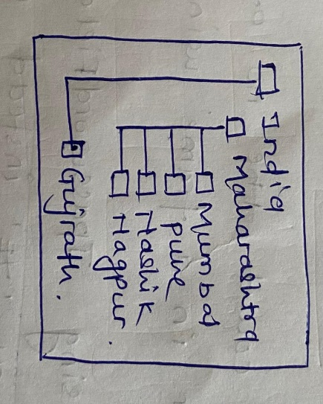

1. Write a program to generate the following output. (Using JTable)

|  |  |  |
| --- | --- | --- |
| ID | Name | Salary |
| 101 | Amit | 5000 |
| 102 | Jay | 10000 |
| 103 | Sachin | 15000 |